Fetch date and temperature from temperature_data where zip code is greater than

300000 and less than 399999.

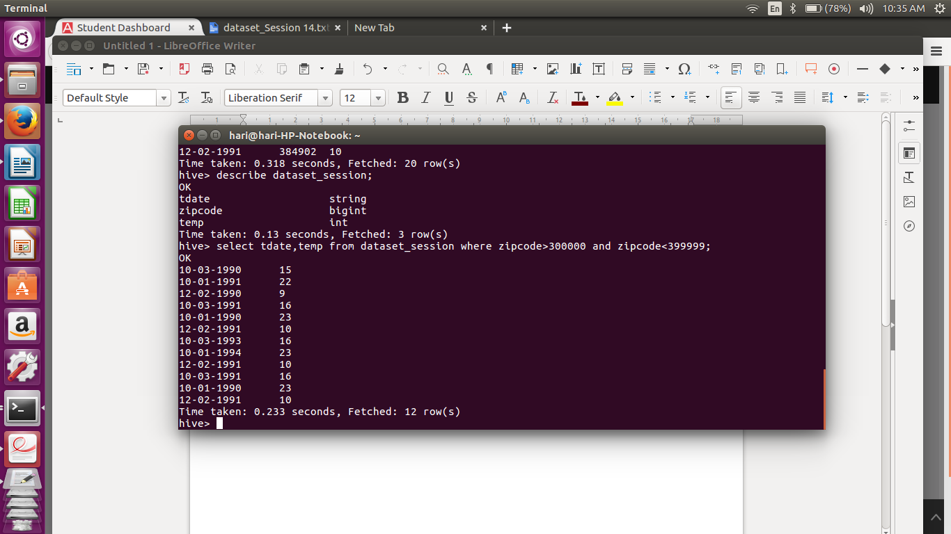

Calculate maximum temperature corresponding to every year from temperature_data

table.

Step 1: First we have converted the dd-mm-yyyy format to unix time format yyyy-mm-dd.

Step 2: Then using the conversion we created a view

Step 3: Using the view we queired the YEAR,TEMP from the view the data.

Hive >create view temp_data_view as select substring(from_unixtime(unix_timestamp(tdate, 'dd-MM-yyyy')),1,10)as date, zipcode, temp from dataset_session;

hive>describe temp_data_view;

hive> SELECT YEAR(date),MAX(temp) from temp_data_view group by YEAR(date);

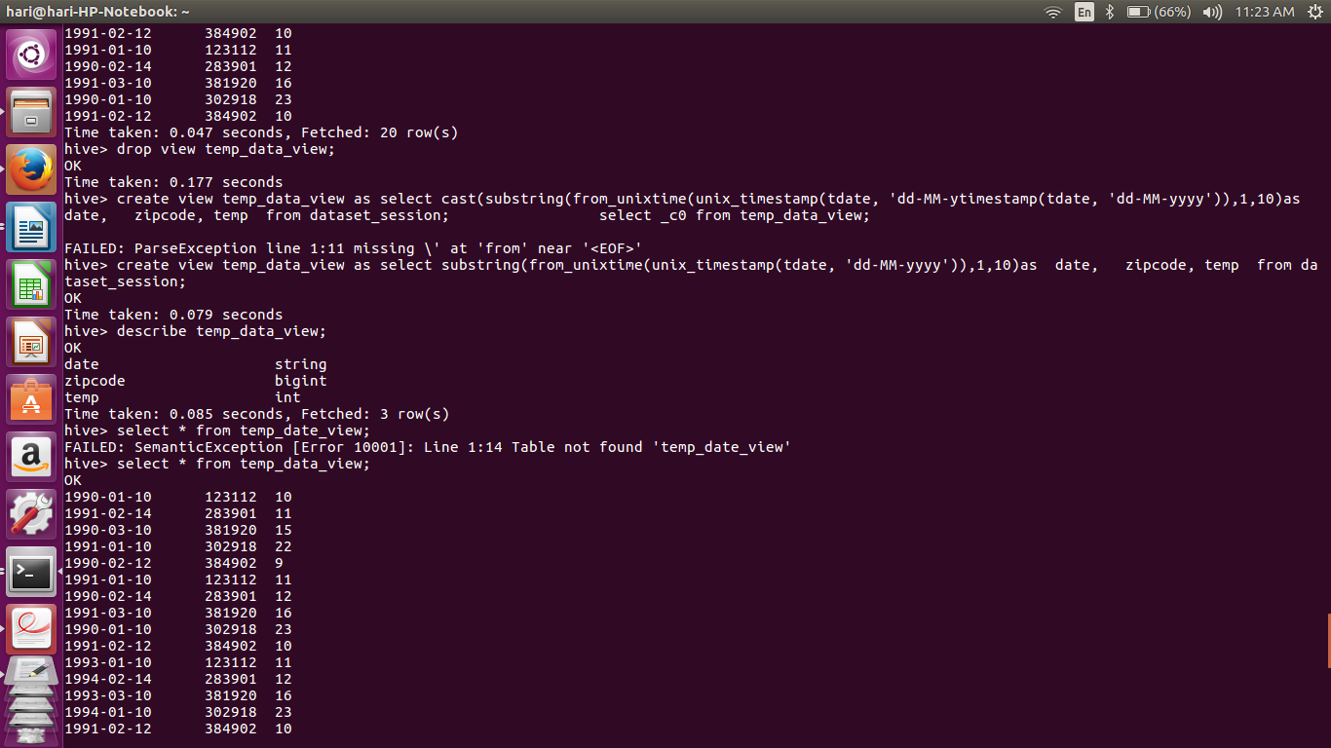

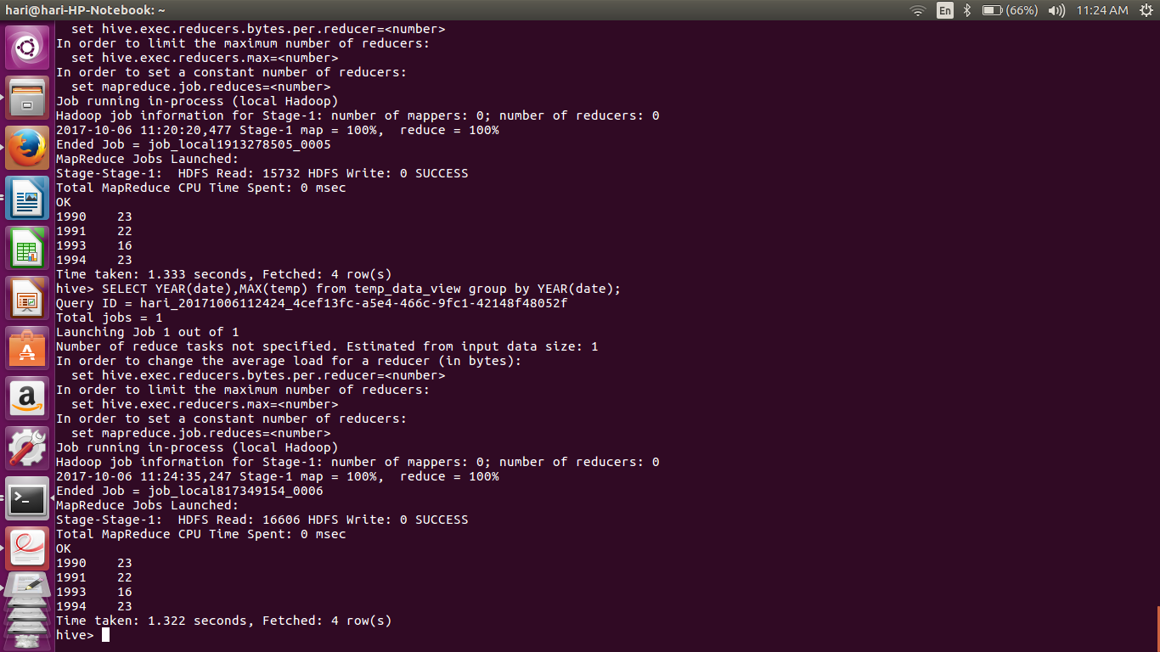

.Calculate maximum temperature from temperature_data table corresponding to those

years which have at least 2 entries in the table.

hive>select MAX(temp),YEAR(date),COUNT(date) from temp_data_view group by temp_data_view;

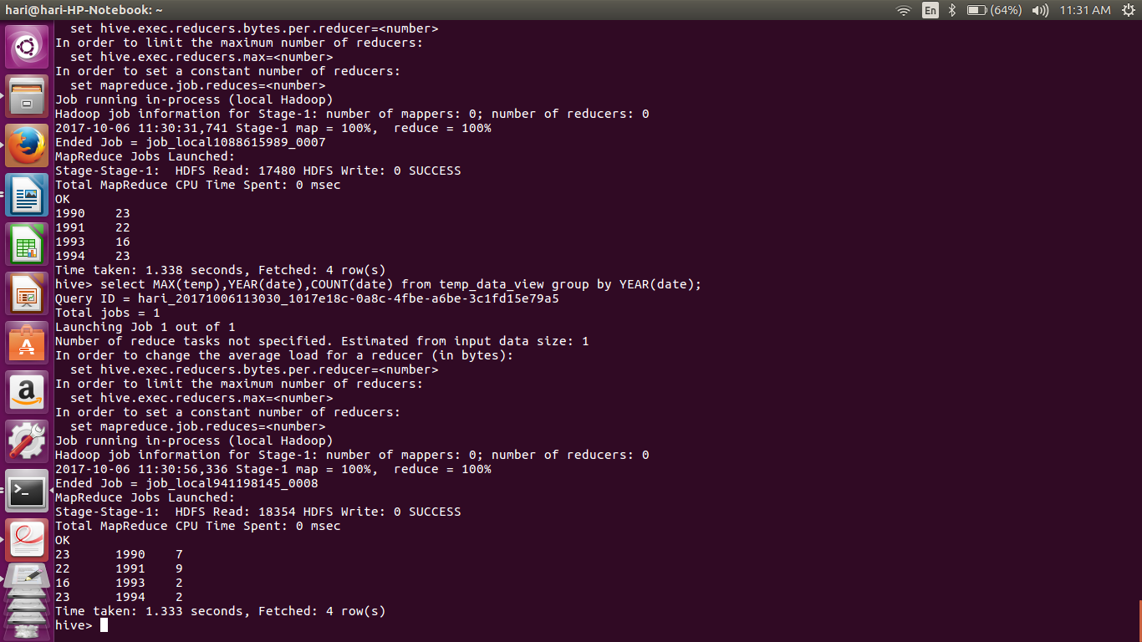

.Create a view on the top of last query, name it temperature_data_vw.

Hive> create view temperature_data_vw as select date,zipcode,temp from temp_data_view;

